Lab 3: Bluetooth Low Energy and Zigbee Communication

Introduction

In this lab, you will first use your Raspberry Pi’s built-in Bluetooth adapter (via the BlueZ stack) to configure the Pi as a BLE peripheral that reports its temperature to a connected BLE server (central device). Through this setup, you will explore the Pi’s GATT services and practice reading from and writing to characteristics. You will then use an SDR (USRP B210) to observe and analyze the spectral characteristics of your BLE connection.

In the second part of the lab, you will assemble a Zigbee network using XBee modules (IEEE 802.15.4) to establish low-power, low-bandwidth wireless communication between your PC and Raspberry Pi. You will also capture and analyze live Zigbee traffic to better understand protocol behavior at the packet level.

Part 1 - Bluetooth Low Energy (BLE) on Raspberry Pi

1.1 Configuring Raspberry Pi as a BLE Peripheral

You will use your Raspberry Pi’s built-in Bluetooth adapter (BlueZ stack) and standard command-line tools.

Ensure the Bluetooth service is enabled and running before you begin:
sudo systemctl enable bluetooth
sudo systemctl start bluetooth

Run the commands below to configure your Raspberry Pi as a simple BLE peripheral that reports its temperature to a connected server. The underlying implementation is based on code by Douglas Otwell:

git clone https://github.com/douglas6/cputemp.git
cd cputemp
python3 cputemp.py

Next, we will connect the peripheral to a server to explore its BLE services and characteristics.

On your mobile device, install the LightBlue app, which will act as our BLE server (central device). It is available on both the App Store and Google Play. You can read more about LightBlue here: https://punchthrough.com/lightblue/

Use the app to scan for nearby BLE devices. Once you locate your peripheral, connect to it.
After establishing the connection, examine the details of the BLE services and characteristics within the app, and use the information to complete the table below.
Field (format) | Value
Device Information Service UUID (Hex)
Temperature Service UUID (Hex)
CPU Temperature Characteristics UUID (Hex)
Temperature Unit Characteristics UUID (Hex)
The displayed CPU/Pi temperature in Fahrenheits (UTF-8 String)
The displayed CPU temperature in Celsius (UTF-8 String). Note: To obtain this value, you must first modify the Temperature Unit characteristic to Celsius using its write property.
Take screenshots of the displayed values within the app and include them in your report as supporting evidence.
Answer the following questions/tasks while completing Part 1.1:
- Briefly describe the difference between advertising and scanning in BLE.
- What is the function of the Device Information Service? What are the typical characteristics commonly found in it and their UUIDs?

Feel free to explore other features and functionalities within the LightBlue app to further familiarize yourself with its capabilities.

1.2 Analyzing BLE Spectrum usage
In this section, you will use a Software Defined Radio (SDR), specifically the USRP B210, as a spectrum analyzer to observe the impact of your BLE connection on the wireless spectrum.
Important: This portion of the lab must be completed physically in JEC 5312, as SDRs are not permitted to be taken outside the lab.
First, ensure that your BLE connection is active, meaning the peripheral is connected to the server.
Next, connect the USRP B210 to a USB port on any of the IoT lab computers in JEC 5312. The B210 can be powered directly through the USB connection for basic spectrum analysis tasks.
Open a terminal on the computer and run the following command:

“uhd_fft --spec A:A -A TX/RX -s 40e6 -g 50 -f 2.412e9”

A new window will appear. Select the “Waterfall” option to display a spectrogram of the wireless environment.
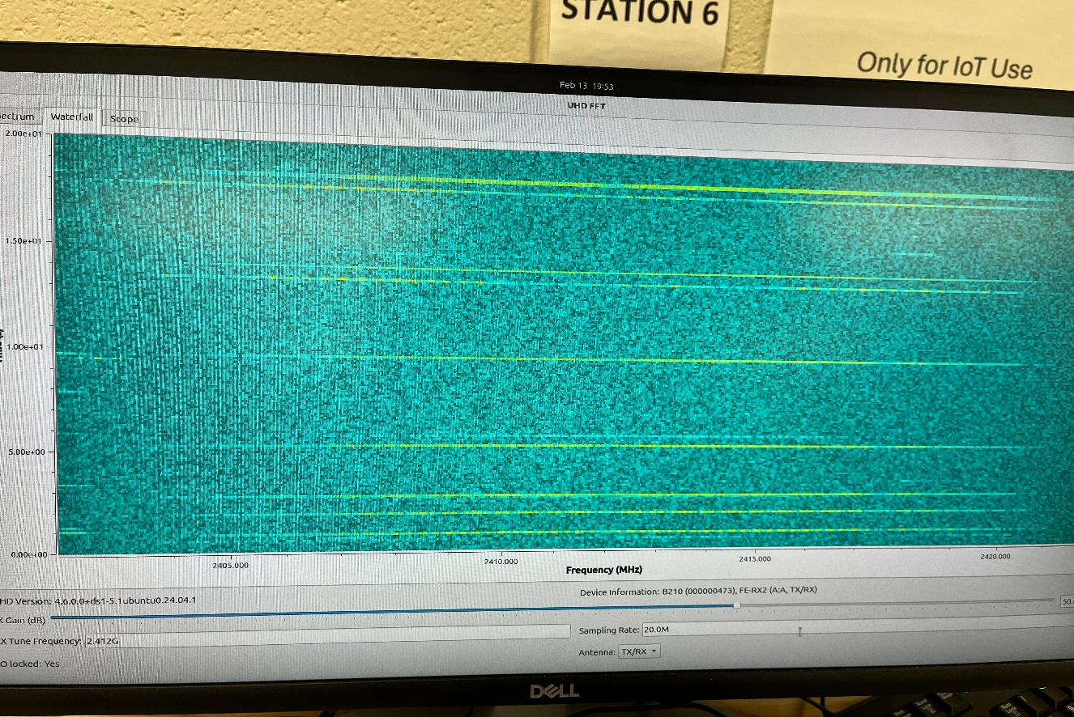

Position the BLE server, peripheral, and USRP B210 as close to one another as possible. If feasible, disable Bluetooth on any other nearby devices.

Carefully observe the spectrogram while the BLE connection is active. Then disable the BLE connection by turning off the Bluetooth modules on both the peripheral and the server and observe the spectrogram again. Next, turn Bluetooth back on, re-establish the BLE connection, and note any changes in the spectrogram.
You may also adjust the tuned frequency to other channels within the 2.4 GHz band and continue observing the spectrogram. Refer to the lecture slides for details on the 2.4 GHz channel allocations.

Based on your observations, answer the following questions:

- During your exploration, which regions of the spectrogram do you believe correspond to your BLE transmissions? In your report, include example spectrogram screenshots with these regions clearly highlighted or circled, and justify why you selected them.

- Based on your observations, does BLE communication use the same channel continuously over time? Explain your answer. If you believe it uses different channels, do you observe some specific pattern in how the channels are selected?

- Do you observe any other types of signals in the spectrogram? What signal do you think they most likely represent? As in Question 1, include example screenshots with the relevant regions clearly marked and explain your reasoning. Based on your observations, what are the key differences between these signals and BLE transmissions?

- If the BLE communication remains active and the devices stay in the same positions for an extended period, such as an entire day, would you expect the spectrogram to always remain the same? Justify your answer.

Part 2 –Zigbee Communication

In this exercise, you’ll use two Zigbee modules from the IoT lab, one connected via USB mini-B to your PC and the other to your Raspberry Pi. We’ll walk you through configuring each XBee adapter and establishing a stable Zigbee link so that your PC and RPi can communicate wirelessly.

2.1. Configure Zigbee as a Receiver
Before you write any code, you must configure one XBee module to act as a listener (receiver) so it can “hear” transmissions from your other Zigbee device. To do this, you will use Digi’s XCTU software to load the provided configuration profile, assign a unique PAN ID, disable coordinator mode, and write these settings to the module before plugging it into your Raspberry Pi.

- Download and install XCTU (http://www.digi.com/support/productdetail?pid=3352) . The software is available for Windows, Mac and Linux. Note you have to download both the driver and the application.
- Plug your Zigbee into your computer’s USB port via a USB cable.
- Download the configuration profile (IoT-Lab5-Zigbee-profile.xpro) from the following https://drive.google.com/file/d/1FnwSmQVJT8IksBH-YWVQhfvgNWuIiASv/view?usp=drive_link
- Discover the radio module connected to your computer.
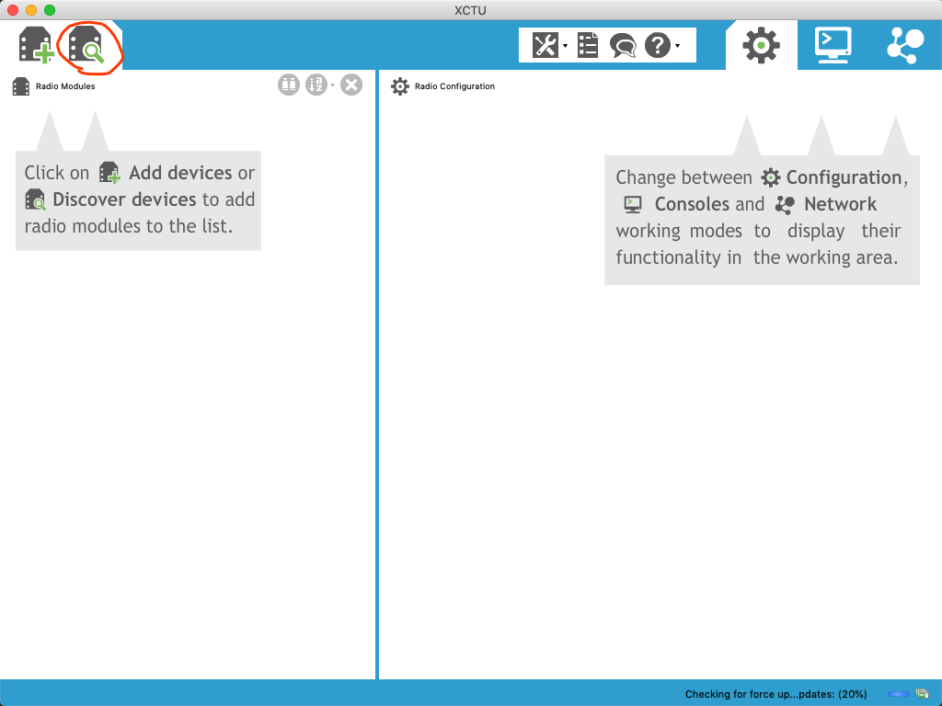

- Your Zigbee device will appear with a label starting with ‘usb...’(MAC) or ‘ttyUSB...’(Linux) or ‘COM’(Windows) depending on your system.
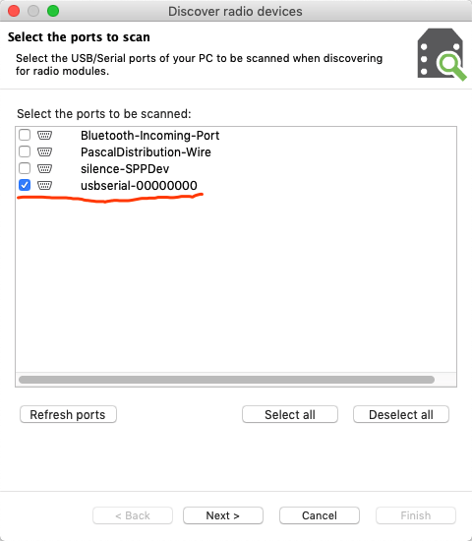

- Add the device discovered by XCTU.

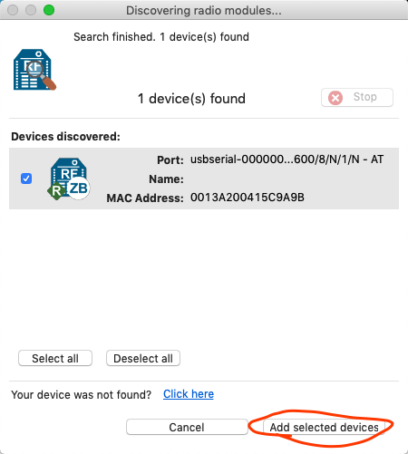

- Under the profile tab click the option for loading a profile and select the downloaded profile file.

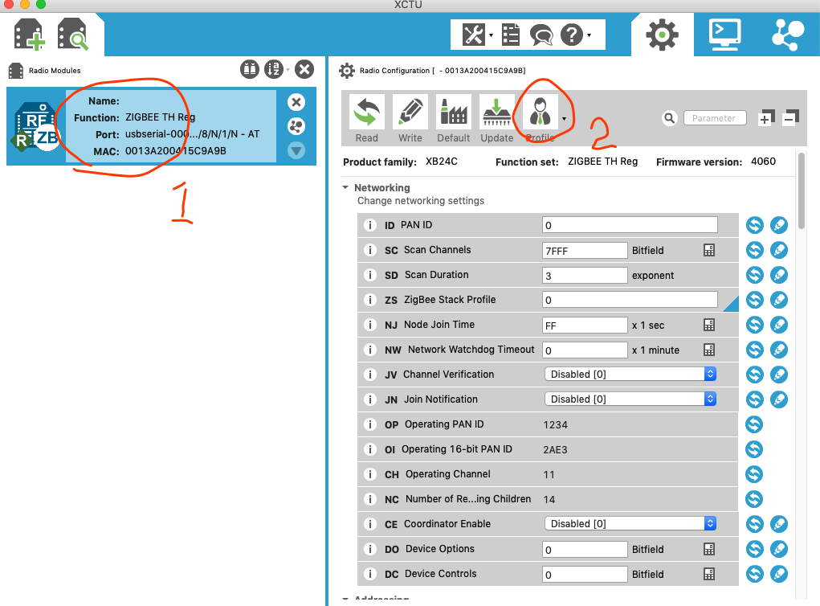

- Next, change the PAN ID to some random number within the allowable range. Avoid using trivial PAN ID because interference may happen if multiple students are trying to setup their pair using the same PAN ID in the lab room. Remember the number you assigned, you will need to enter the SAME number for PAN ID of your transmitter. Disable the Coordinator Enable and click ‘Write’.
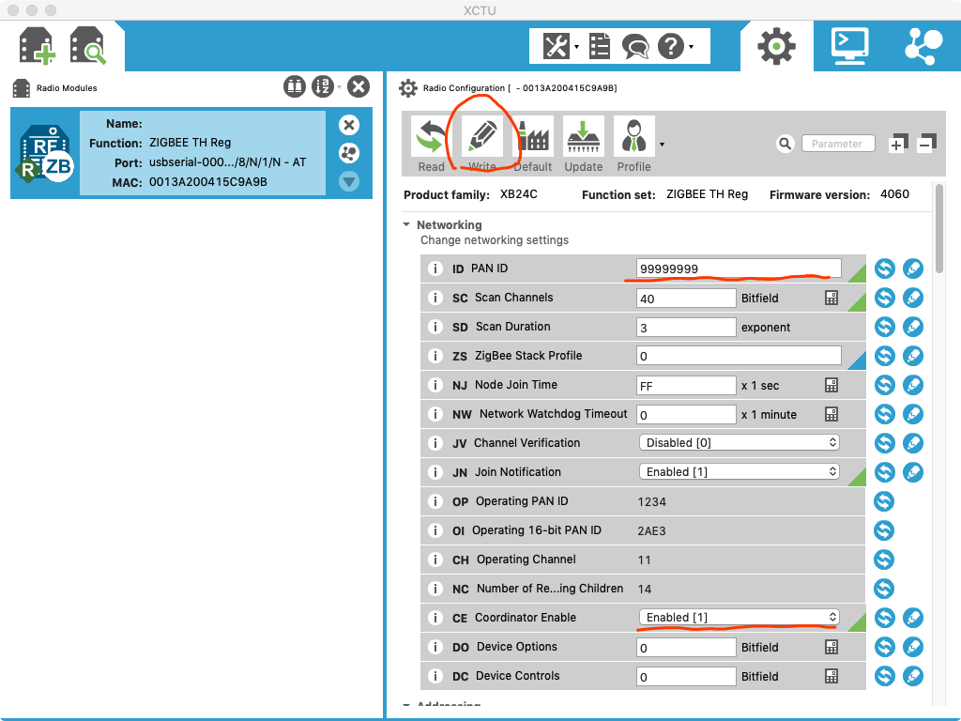

- Before coding your receiver or transmitter, you would have to install the ‘digi-xbee’ package:

# for python3
sudo apt-get install python3-dev python3-pip -y
pip3 install digi-xbee

# for python2
sudo apt-get install python2-pip -y
pip2 install digi-xbee

Code for Zigbee receiver:
from digi.xbee.devices import XBeeDevice

"""
Modify the device_url based on your port name
For Windows, go to Device Manage > Ports (typically COM7)
For Mac, do ‘ls /dev/cu.*’ in terminal (typically /dev/cu.usbserial-00000000)
For RPi, do ‘ls /dev/ttyUSB*’ in terminal (typically /dev/ttyUSB0)
"""
device_url = "/dev/ttyUSB0"
device = XBeeDevice(device_url, 9600)
device.open()

while True:
xbee_message = device.read_data()
if xbee_message:
data = xbee_message.data
sender = xbee_message.remote_device
timestamp = xbee_message.timestamp
msg = """{time} from {sender}\n{data}""".format(time=timestamp, sender=sender, data=data.decode('UTF8'))
print(msg)

device.close()

2.2 Set up another Zigbee module as a Transmitter

The general configuration is almost the same as 3.1, but make sure to Enable the Coordinator Enable option.

Code for Zigbee transmitter:
from digi.xbee.devices import XBeeDevice
import time

"""
Modify the device_url based on your port name
For Windows, go to Device Manage > Ports (typically COM7)
For Mac, do ‘ls /dev/cu.*’ in terminal (typically /dev/cu.usbserial-00000000)
For RPi, do ‘ls /dev/ttyUSB*’ in terminal (typically /dev/ttyUSB0)
"""
device_url = "/dev/cu.usbserial-00000000"
device = XBeeDevice(device_url, 9600)
device.open()

while True:
print("please write the message you want to send")
msg = input()
device.send_data_broadcast(msg)
try:
device.send_data_broadcast(msg)
except Exception as e:
print(e, "No One Listening")
print(msg)
time.sleep(0.01)

device.close()

2.3 Analyzing a Zigbee packet
In this section, you will analyze a transmitted Zigbee packet using your PC. The XCTU application provides a console interface that allows you to observe some link-layer details of captured packets.

Complete the following steps:

- Ensure both Zigbee modules are properly connected and configured, with your host machine acting as the transmitter and the Raspberry Pi acting as the receiver

- Configure a third Zigbee module as a receiver and connect it to a separate USB port on your PC. This module will serve as the sniffer. Confirm that both Zigbee modules connected to your PC are detected and visible in XCTU.

- Select the sniffer module in XCTU. Under the Working Modes section, choose Console mode and open the connection to begin monitoring captured packets.

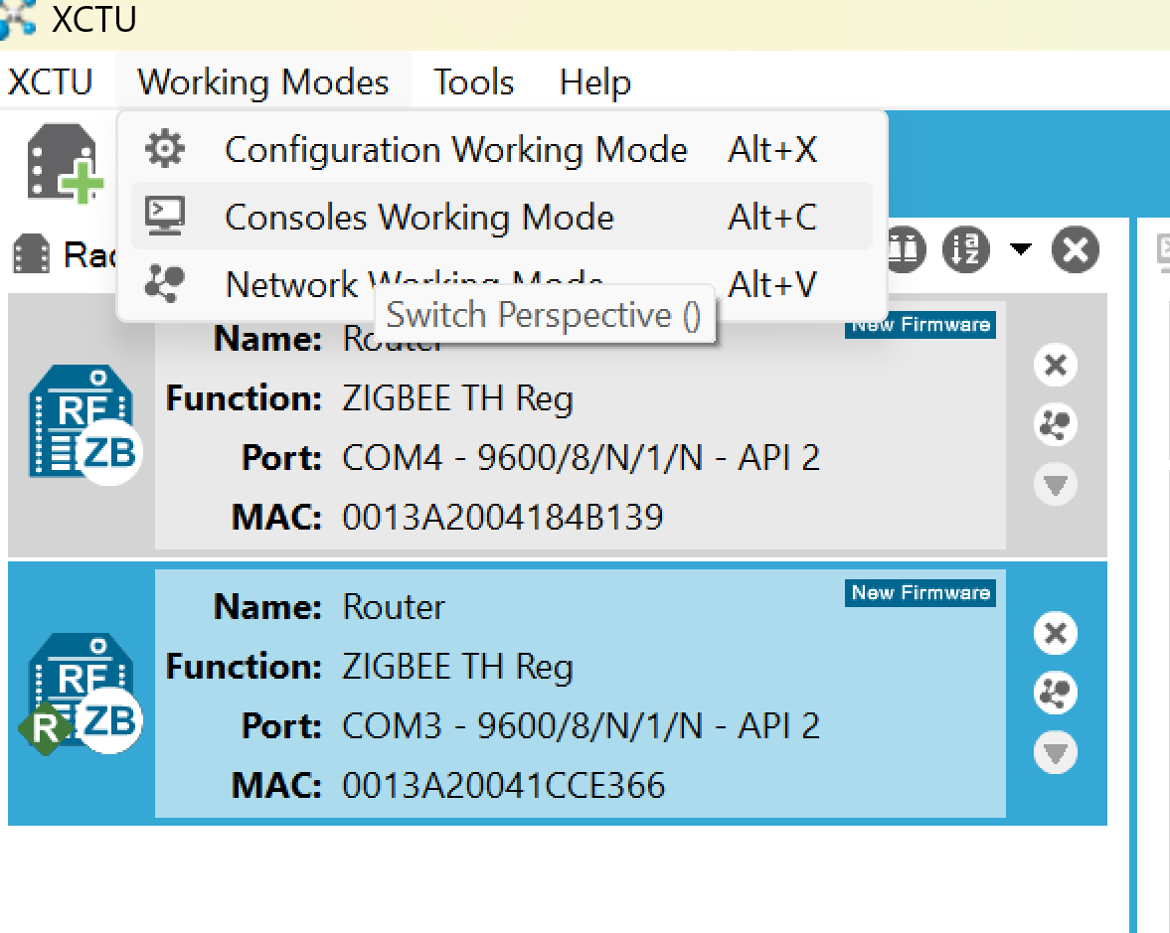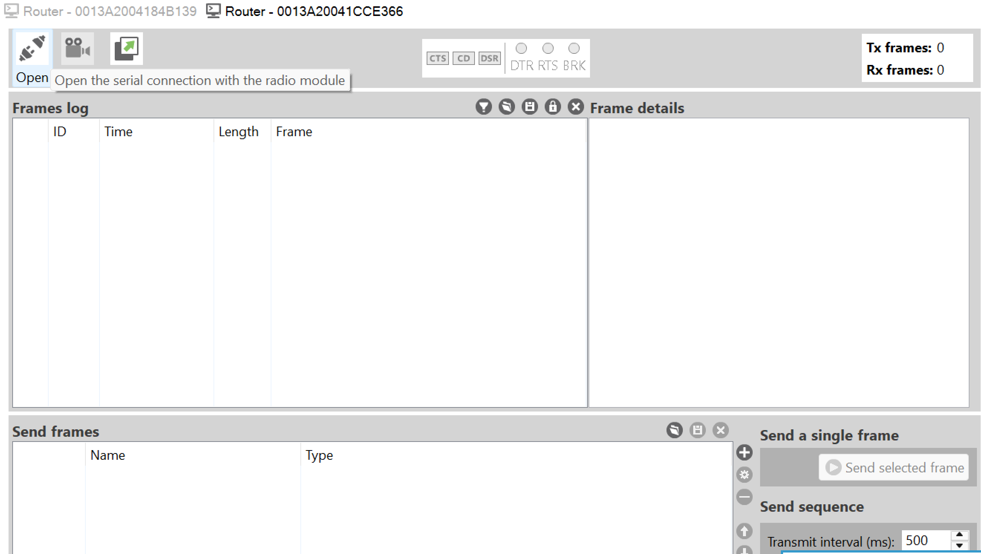

- Using your Python scripts from Sections 2.1 and 2.2, transmit a new message from the PC (transmitter) to the Raspberry Pi (receiver). The corresponding packet and some of its fields should appear in the frame log within XCTU.

- Answer the following questions:
- List all packet fields you observe in a clear table format, including both the field name and its corresponding value.
- How many source addresses are present in the packet? If more than one, explain why multiple source addresses exist and how they are assigned.
- Suppose you recreate the same Zigbee setup but using different XBee modules. For each field, would you always expect its value to remain constant? Justify your reasoning.
- Sniffing demonstrates that Zigbee traffic can easily be captured by nearby devices. How would you defend against eavesdropping in this scenario? Is there any packet information that may still be observable to an attacker despite your defense?

2.4 This task is only for ECSE 6660 Students (Implement Message Encryption).

In this task, you will extend the provided Zigbee transmitter and receiver code to integrate AES encryption using Python’s cryptography library. Messages should be encrypted before transmission and decrypted upon reception, with minimal changes to the user interface. The encryption process should ensure secure communication while maintaining a seamless user experience. for a few seconds

Extend the existing Zigbee transmitter and receiver code to integrate AES encryption using Python’s cryptography library or any other library. Encrypt messages before transmission and decrypt them upon reception, ensuring that these processes operate seamlessly in the background with minimal changes to the user interface.

Deliverables
For ECSE 4660 Students:
- Submit your answers to all questions in Parts 1 and 2. Include the completed table for Part 1, along with all required screenshots for both sections.

- Provide screenshots showing that your Zigbee receiver in Part 2.1 is successfully receiving messages from the transmitter in Part 2.2.

For ECSE 6660 Students:
In addition to the deliverables required for undergraduate students, also include:
- The modified transmitter and receiver scripts that integrate AES encryption/decryption with clear inline comments.
- Screenshots or log files that verify successful encrypted message transmission and decryption.

If you have any questions, please turn to the Lab TA or ask on Piazza:

· Chibuikem Ezemaduka (ezemac@rpi.edu)

